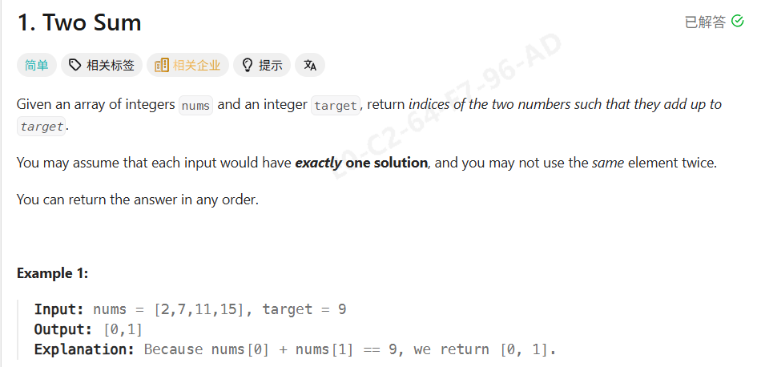
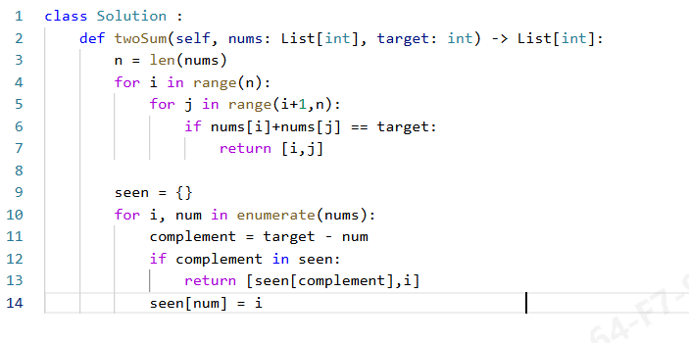
你一开始 不要直接写你贴的双重循环代码，而是先说
“I’ll start with a brute-force solution to clarify the problem, then optimize it using a hash map.”
先讲暴力解（但不写 or 快速带过）
你可以指着白板/屏幕说：
“The brute-force approach is to check every pair of numbers using two loops and return the indices when their sum equals the target.
This works, but it takes O(n²) time.” 【O of n squared time】
如果面试官点头 👉 马上切换优案
开始写 Hash Map 解（边写边解释）
To optimize this, I can use a hash map to store the numbers I’ve already seen and their indices.
For each number, I check whether the complement target - num already exists in the map.”
This dictionary maps a number to its index, so I can look up the complement in O(1) time. 【O of one time】
【这个字典把每一个数字映射到它对应的下标（索引）】
在计算机里：
map A to B 的意思是
👉 用 A 作为 key，去定位 B 这个 value
I iterate through the array once, keeping track of both the index and the value
For the current number, I calculate the value I need to reach the target.
“If the complement already exists in the map, it means I’ve seen a previous number that can form the target sum with the current one, so I return their indices.
If not found, I store the current number and its index for future lookups.
This solution runs in O(n) time because each lookup in the hash map is constant time, and it uses O(n) extra space.

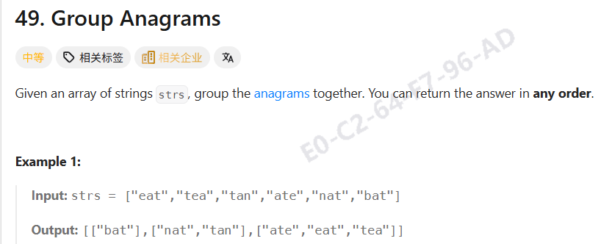
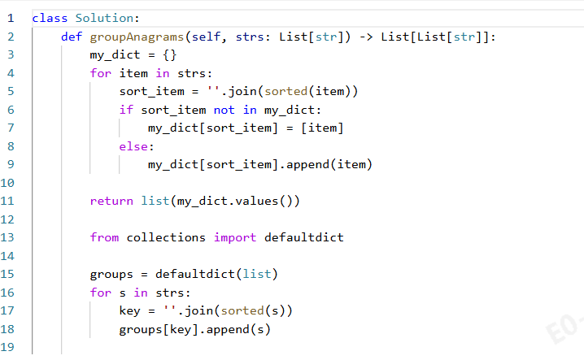
先说整体思路（不写代码）
Anagrams have the same characters, just in different orders.
If I sort each string, all anagrams will have the same sorted form, which I can use as a key.
写 defaultdict(list) + 解释
“I use a defaultdict of lists, where each key represents a canonical form of a string, and the value is a list of strings that belong to the same anagram group.
“I iterate through each string in the input list.”
I sort the characters in the string and use the sorted string as the key, because all anagrams share the same sorted form.
Then I append the original string to the list corresponding to that key.
Finally, I return all the grouped anagrams as a list of lists.
复杂度怎么说（一定要主动说）
If there are n strings and each string has length k, sorting each string takes O(k log k), so the total time complexity is O(n · k log k).
The space complexity is O(n · k) due to the hash map.

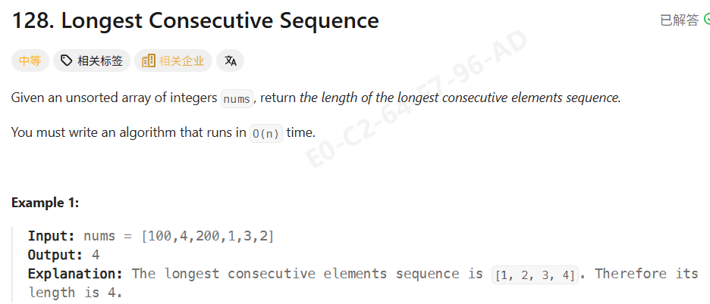
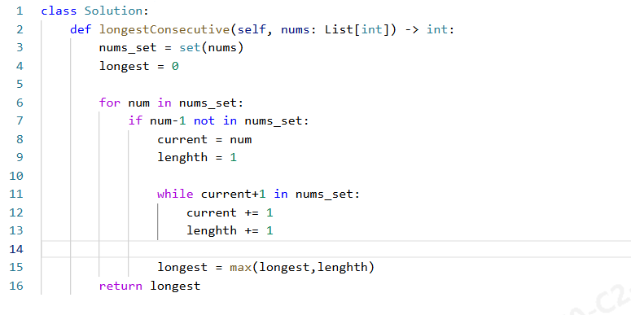
I convert the list into a set so I can check whether a number exists in O(1) time and also remove duplicates.
This variable keeps track of the longest consecutive sequence length found so far.”
“I iterate through the set instead of the list to avoid duplicate work.”
I only start counting when the current number is the beginning of a sequence.
If num - 1 doesn’t exist, then num must be the start of a consecutive sequence.
I initialize the current number and the length of the sequence.”
“I keep moving forward as long as the next number exists in the set, and count the length of the sequence.”
After finishing one sequence, I update the global maximum length
Finally, I return the longest consecutive sequence length
Although there is a nested while loop, each number is visited at most once because we only expand sequences starting from their smallest element.”
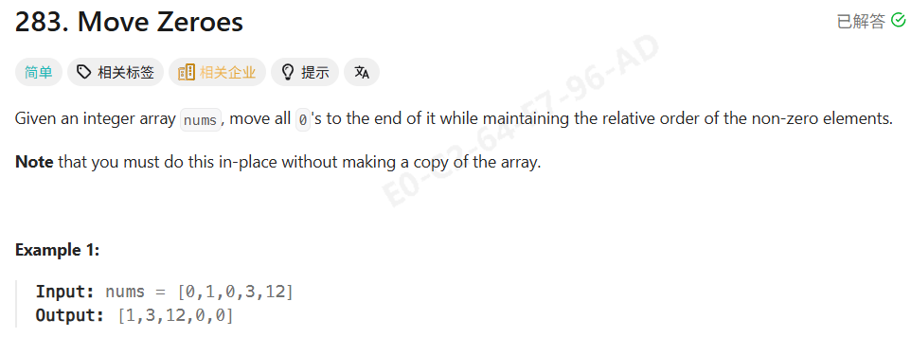
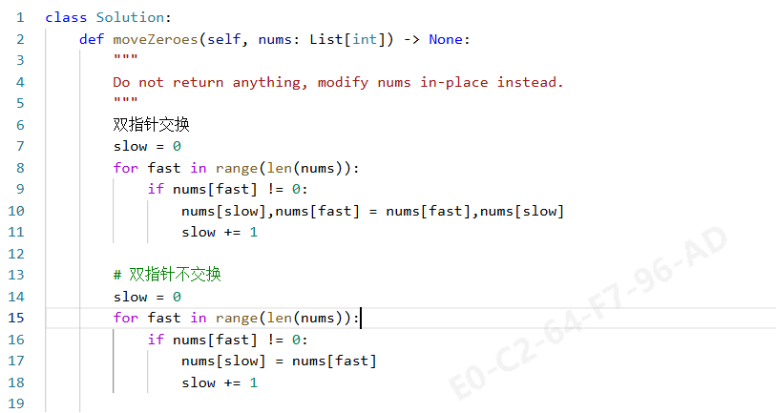
“I use two pointers.
The slow pointer tracks the position where the next non-zero element should be placed.”
The fast pointer scans the array from left to right.”
Whenever I find a non-zero element…”
“I swap the non-zero element to the position pointed by slow,
then move slow forward.”
“Because fast always moves forward and slow only advances when a non-zero is found, the relative order of non-zero elements is preserved.”
The algorithm runs in O(n) time because each element is visited once,
and it uses O(1) extra space since the array is modified in place.”
20 秒英文面试总结版（建议背）
“I use a two-pointer approach.
The fast pointer scans the array, and the slow pointer tracks where the next non-zero element should go.
Whenever I encounter a non-zero value, I swap it to the slow position and move slow forward.
This keeps all non-zero elements in order and moves zeros to the end in O(n) time and O(1) space.”

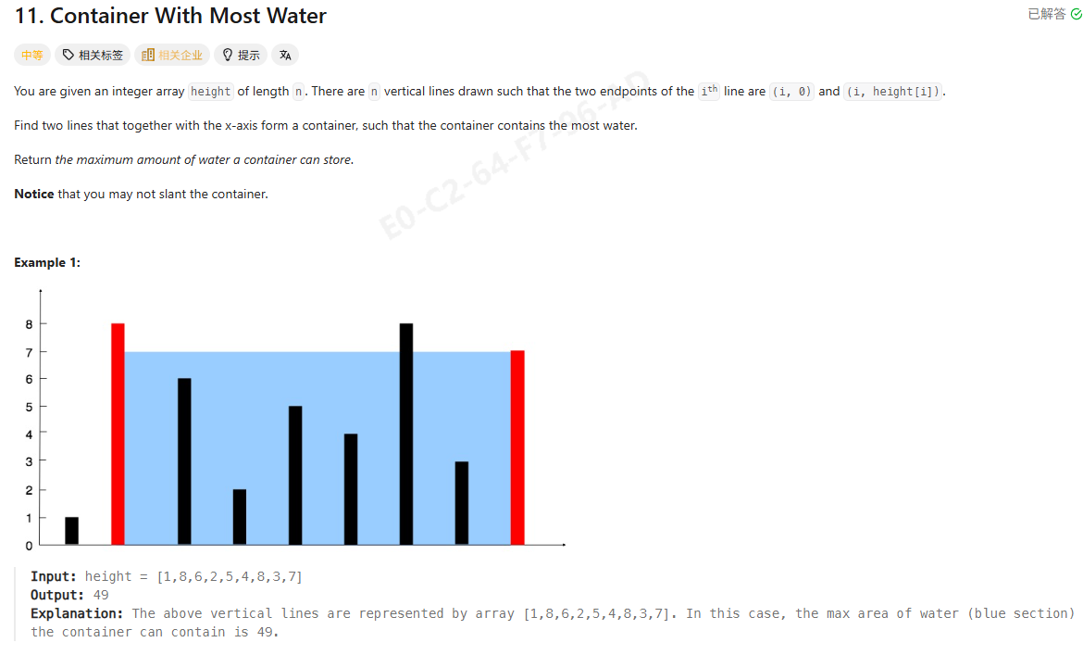
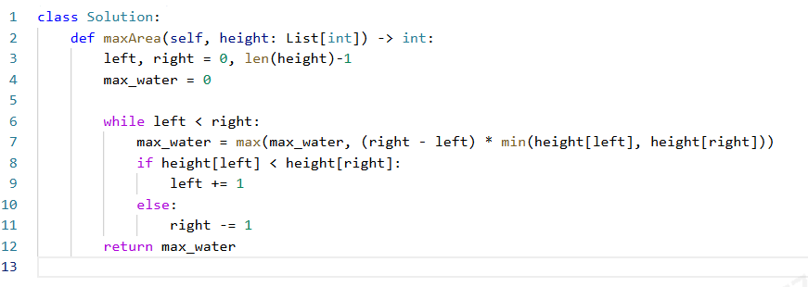
20 秒英文面试总结版（建议直接背）
“I use a two-pointer approach starting from both ends of the array.
At each step, I calculate the area using the distance between the pointers and the shorter height.
Since the area is limited by the shorter line, I move the pointer pointing to the shorter height to potentially find a taller one.
This guarantees an O(n) time complexity with constant space.”

面试中你该怎么解释「为什么移动短板」
这是 必考追问，你可以这样说：
“The area is limited by the shorter height.
Moving the taller line will not increase the area because the height is still bounded by the shorter one.
Only by moving the shorter line do we have a chance to find a taller boundary and increase the area.”

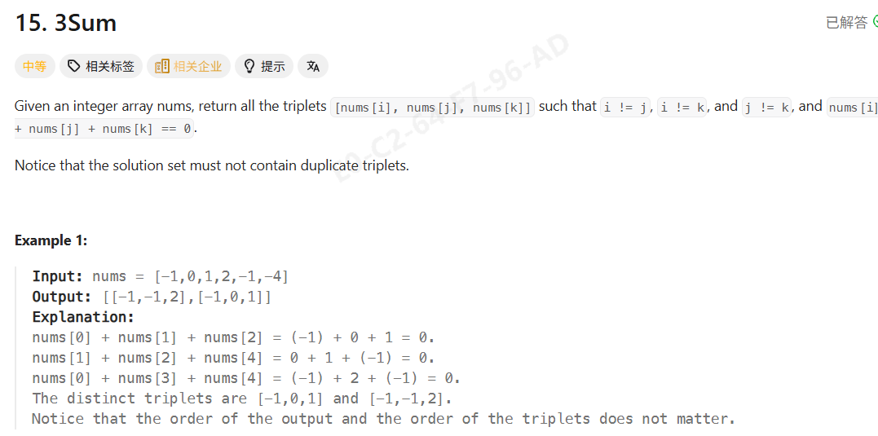
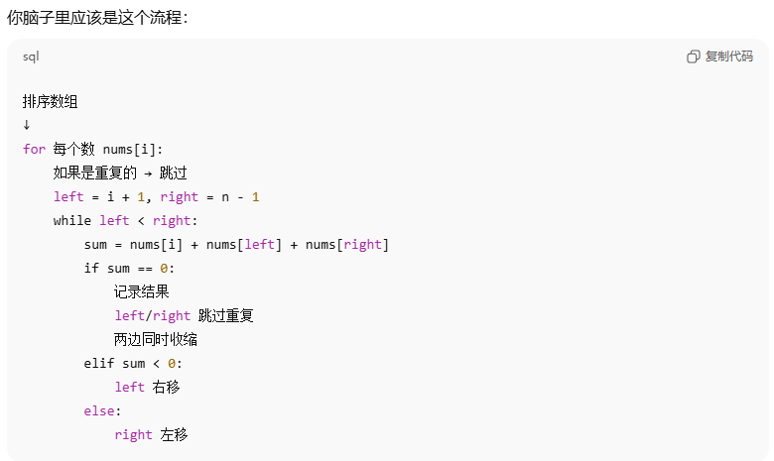
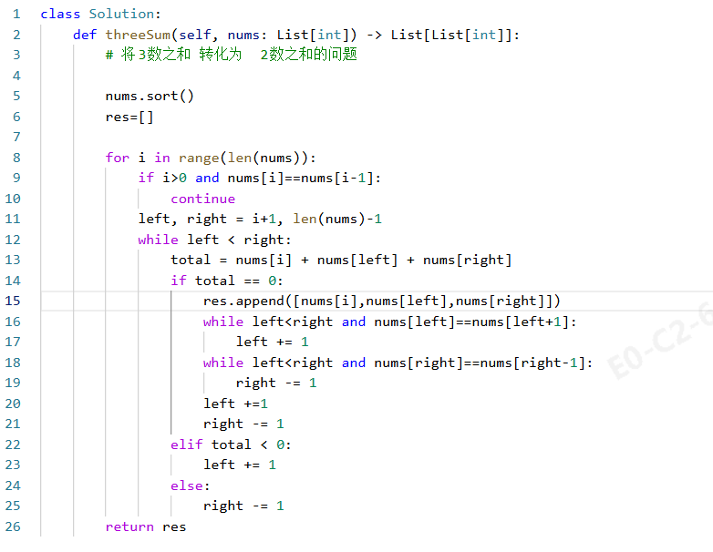
“Before writing the code, let me briefly explain my approach.”
“My approach is to reduce the 3Sum problem into a 2Sum problem.”
First, I sort the array. Sorting allows me to use the two-pointer technique and also makes it easy to skip duplicates later.
Then I iterate through the array and fix one number at a time. For each fixed number, the problem becomes finding two numbers in the remaining part of the array whose sum equals the negative of the fixed number.
To solve this 2Sum subproblem, I use two pointers: one starting from the element right after the fixed number, and the other starting from the end of the array. I move the pointers inward based on whether the current sum is smaller or larger than zero.
To avoid duplicate triplets, I skip duplicate values for the fixed number, and after finding a valid triplet, I also skip duplicate values for both pointers before continuing.
This approach ensures that each valid triplet is found only once, and the overall time complexity is O(n²) with constant extra space.

